**Experiment 6- 3d hut using blender**

[**https://drive.google.com/file/d/1mDm46cfpOblJOtaeSDrrFXbf1CosvRzb/view?usp=sharing**](https://drive.google.com/file/d/1mDm46cfpOblJOtaeSDrrFXbf1CosvRzb/view?usp=sharing)

**Step 1: Merge Two Simple Shapes**

[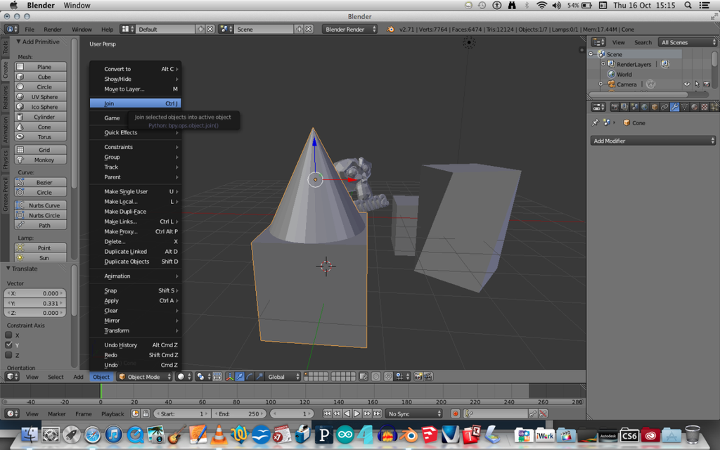](https://cdn.instructables.com/ORIG/FEX/OBFT/I4SCIQDR/FEXOBFTI4SCIQDR.png?auto=webp&frame=1&width=1024&fit=bounds&md=ffd3ab72c19dd9bcc950b818a6b6902f)

Once you have opened Blender software, there should already be a simple cube shape placed on the net, if not, click the shape button on the left panel and then insert a cube, and then also insert a cone shape. These shapes can be moved by dragging the blue, red and green arrows from each side of the shapes.

Select both shapes and click on the small spanner on the top right panel, and in edit mode, select ‘subdivide’ from the left hand menu, and click it a few times in order to add different sections to the shapes so they can be later modified. This will then allow you to select points, sides and edges of the subdivisions so that you can manipulate and change the shape. Drag the edges of the cone so that it creates corners which match the corners of the cube.

Position the cone on top of the cube so that they touch, and then hold the shift button and right click on both shapes, then click ‘object’ in the bottom left corner, and selected ‘join’. This should make the object as one.

**Step 2: Add Door to the hut**

Select the surfaces of some subdivided surfaces where you want your windows to be whilst in edit mode (you can do all 4 windows in one go). Then you can click on ‘extrude region’ from the left and menu and drag the lever to the left side of your screen with your mouse in order to push a window shape into the side of the cube.

Next select the two subdivided sections which lie above each window and subdivide them once more so that there are four. This will then allow you to create a more detailed curve to the windows. Once this is done, in edit mode, select the edge tool from the bottom panel and then use the 'translate' transformation manipulator to pull in the edges so they appear curved.

The same tools are used when creating the door, however I chose to have the door sticking out rather than going into the house like the windows.

**Step 3: Scale the hut**[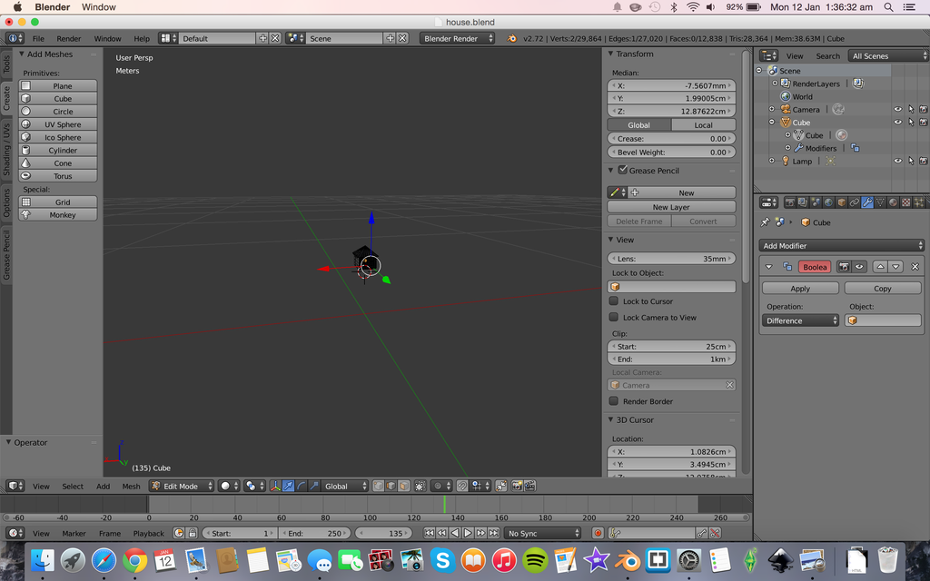](https://cdn.instructables.com/ORIG/FVT/Y9JP/I4SCJA2I/FVTY9JPI4SCJA2I.png?auto=webp&frame=1&width=1024&height=1024&fit=bounds&md=59d4fc691867b1de1efc272dc216e91c)

Firstly go to the scene tab and change the units to metric so that they are in metres and centimetres. Then make sure that the house is selected and press 'n' so that you open up the right hand toolbar. You then need to scale the house down by changing the dimensions, I used 5cmx5cmx5cm so that it would be quite small.

You may notice that the house becomes very small and you cannot zoom in on it, to change this scroll down to where it says 'clip' and type in 1cm, this will then allow you to zoom in a lot closer to the shape.

**Step 4: Add a Hole in the hut (only for 3D Printing)**

[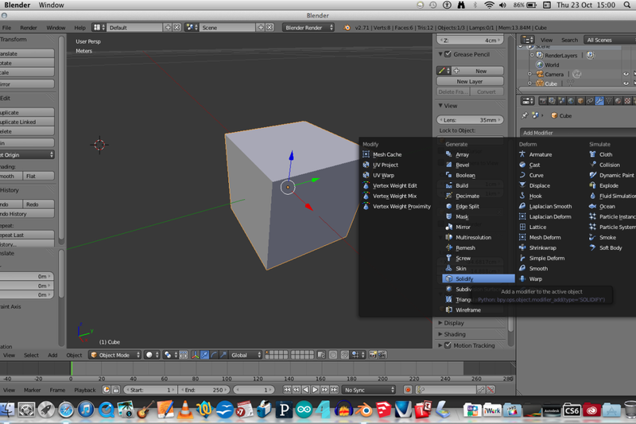](https://cdn.instructables.com/ORIG/FP6/YZ3O/I4SCIQKE/FP6YZ3OI4SCIQKE.png?auto=webp&frame=1&width=1024&fit=bounds&md=556dbb0e3451f0706d5a4bbc0985acb7)

[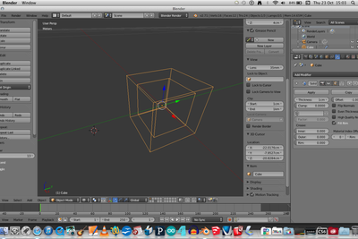](https://cdn.instructables.com/ORIG/F5A/88TD/I4SCIQN7/F5A88TDI4SCIQN7.png?auto=webp&frame=1&width=1024&fit=bounds&md=bd8765d49f8ec24bde36288ad8640dbc)

[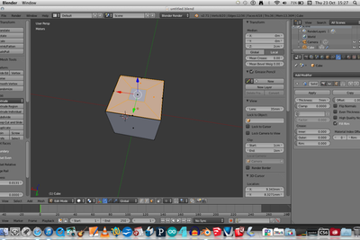](https://cdn.instructables.com/ORIG/F8A/CFT7/I4SCIQ85/F8ACFT7I4SCIQ85.png?auto=webp&frame=1&width=1024&fit=bounds&md=5ce8094fa49d158277f0fe376cb8f7c7)

Add a solidify modifier by going to the spanner icon in the right hand menu. This will make the thickness of the wall of the cube thicker (1cm thicker) so that when printed with the 3D printer it will be hollow and therefore save expensive resources. You can see the effect by entering wire mode.

You finally need to add a 2mm hole to the object so that the powder can escape from the middle when it is being made in the 3D machine. To do this select a face on the bottom side of the house and click the ‘i’ key, this will then allow you to create an additional face within the face which you can alter the size of by dragging and clicking. Then when you have decided on the size, you need to right click and use the delete tool on this created shape in order to form a hole.

**Step 5: Mini 3D hut**

